**Digital Object Identifier (DOI)**

**Configuration**

[DataCite API](https://support.datacite.org/docs/mds-api-guide) is used to create DOI. Configure the API access point in the admin console > settings:

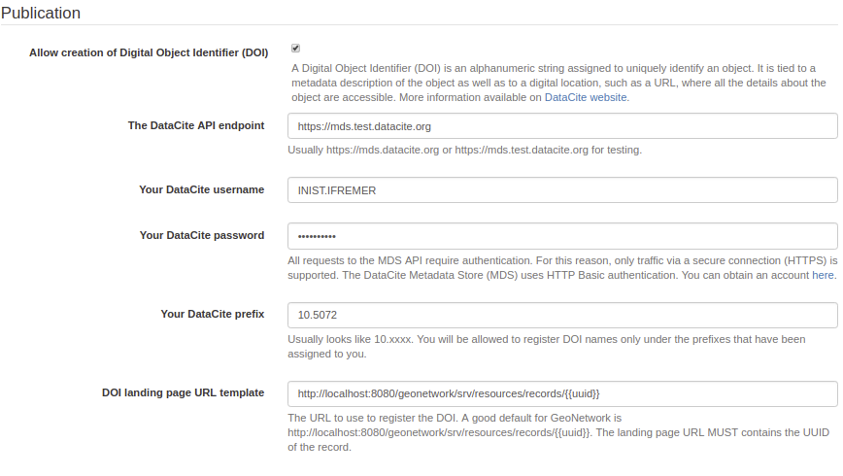

A record can be downloaded using the DataCite format from the API using: <http://localhost:8080/geonetwork/srv/api/records/da165110-88fd-11da-a88f-000d939bc5d8/formatters/datacite?output=xml>

**Creating the DOI**

Once configured, DOI can be created using the interface. DOI is created on demand. It means that a user must ask for creation of a DOI. When created, the task is notified by email to the reviewer of the group (by default, can be configured for administrator only).

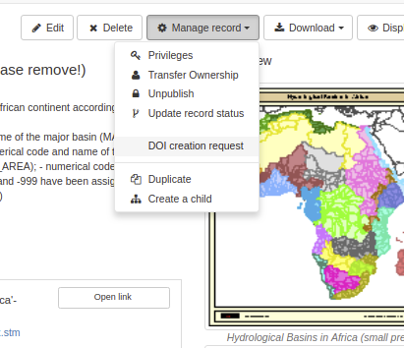

The task is assigned to a specific user. An optional due date and comment can be defined:

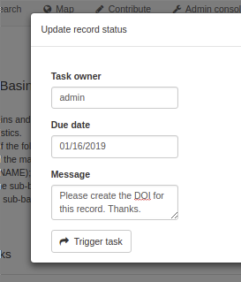

After submission of the task, the task owner is notified by email (if the mail server is configured, see admin console > settings). The task can then be resolved in the admin console > information > versionning section.

For DOI creation, the task is a 2 steps actions:

* First check if all prerequisite are covered (below the record is not valid in DataCite format)

The DataCite format requires some mandatory fields:

* Identifier (with mandatory type sub-property)
* Creator (with optional given name, family name, name identifier and affiliation sub-properties)
* Title (with optional type sub-properties)
* Publisher
* PublicationYear
* ResourceType (with mandatory general type description subproperty)

The mapping with ISO standards is the following:

| **Property** | **ISO 19139** | **ISO 19115-3** |
| --- | --- | --- |
| Identifier | gmd:MD_Metadata/gmd:fileIdentifier/*/text() | mdb:MD_Metadata/mdb:metadataIdentifier/*/mcc:code/*/text() |
| Creator | gmd:identificationInfo/*/gmd:pointOfContact with role ‘pointOfContact’ or ‘custodian’ | mdb:identificationInfo/*/mri:pointOfContact with role ‘pointOfContact’ or ‘custodian’ |
| Title | gmd:identificationInfo/*/gmd:citation/*/gmd:title | mdb:identificationInfo/*/mri:citation/*/cit:title |
| Publisher | gmd:distributorContact[1]/*/gmd:organisationName/gco:CharacterString | mrd:distributorContact[1]/*/cit:party/*/cit:organisationName/gco:CharacterString |
| PublicationYear | gmd:identificationInfo/*/gmd:citation/*/gmd:date/*[gmd:dateType/*/@codeListValue = ‘publication’] | mdb:identificationInfo/*/mri:citation/*/cit:date/*[cit:dateType/*/@codeListValue = ‘publication’] |
| ResourceType | gmd:hierarchyLevel/*/@codeListValue | mdb:metadataScope/*/mdb:resourceScope/*/@codeListValue |

The mapping can be customized in:

* ISO19139 [source file schemas/iso19139/src/main/plugin/iso19139/formatter/datacite/view.xsl](https://github.com/geonetwork/core-geonetwork/tree/master/schemas/iso19139/src/main/plugin/iso19139/formatter/datacite/view.xsl)
* ISO19115-3.2018 [source file schemas/iso19139/src/main/plugin/iso19139/formatter/datacite/view.xsl](https://github.com/geonetwork/core-geonetwork/tree/master/schemas/iso19139/src/main/plugin/iso19139/formatter/datacite/view.xsl)

See <http://schema.datacite.org/meta/kernel-4.1/doc/DataCite-MetadataKernel_v4.1.pdf> for more details on the format.

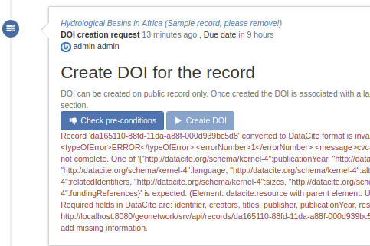

A DOI may already be assigned for a record:



In such case the DOI needs to be removed first.

* After validation, create the DOI

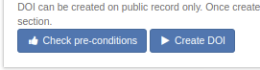

The DOI is then added to the metadata record:

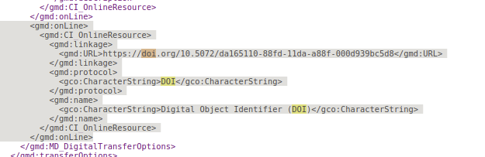

**DOI API**

The REST API allows to access the DOI related operations:

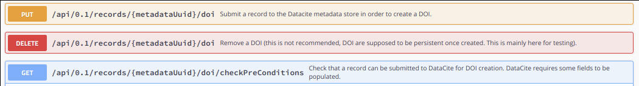

The check preconditions API returns exception if one of the pre requisite is not met:

* DataCite API is not configured
* Record is not public
* Record already has a DOI
* Record is not valid for DataCite (ie. XSD errors returned by DataCite XSD validation)

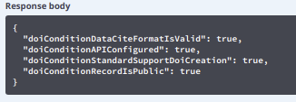

When a DOI is created, the response return the following details:

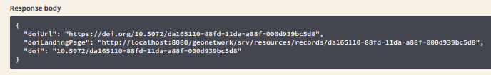

The DOI is added to the metadata record using the following encoding:



**Examples**

* [Comment créer un DOI à partir de l’outil de catalogage Geonetwork, Annick Battais](https://sist19.sciencesconf.org/data/pages/SIST19_A_BATTAIS.pdf)